KILNAMANAGH KIDS
SAFETY STATEMENT
Including Risk Assessment

SAFETY STATEMENT

INCLUDING RISK ASSESSMENTS
This policy is available online.

CONTENTS
PART A – SAFETY STATEMENT AND APPENDICES 4
SECTION 1 – HEALTH AND SAFETY POLICY 4
1.0 – Health and Safety Policy 5
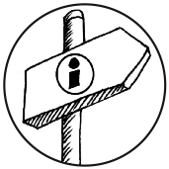1.1 – Business/Company Information 6
SECTION 2 – SAFETY ARRANGEMENTS 7
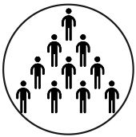2.0 – Roles and Responsibilities 8
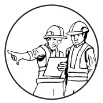2.0.1 – Persons Responsible for Performing Tasks 9
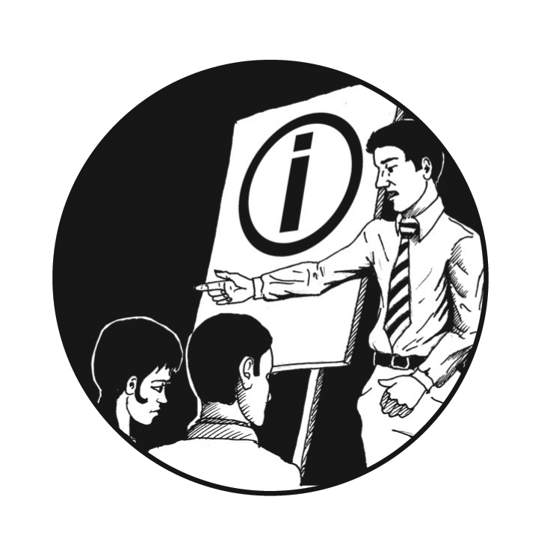2.1 – Competence and Training Requirements 9
2.2 – Consultation and Participation 10
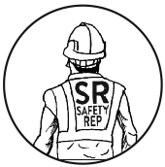2.3 – The Safety Representative 11
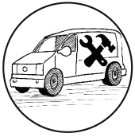2.4 – Contractors’ Responsibilities 12
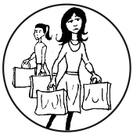2.5 – Visitors 12
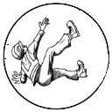2.6 – Accident Reporting and Investigation 13
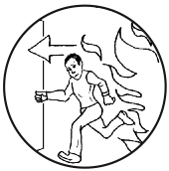2.7 – Emergency Procedures 14
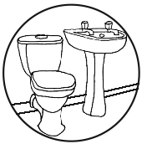2.8 – Welfare Facilities and Workplace Requirements 16
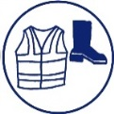2.9 – Personal Protective Equipment 17
2.10 – Pregnancy At Work 18
2.11 – Young Persons 19
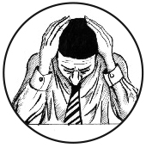2.12 – Work-Related Stress and Dignity at Work 19
APPENDICES 20
Appendix 1 – Forms and Records 21
Appendix 2 – Emergency Information 27
Appendix 3 – Accident/Incident Investigation Form 29
Appendix 4 - Safety Data Sheets/Reports for Hazardous Substances 32
PART B – RISK ASSESSMENT AND ACTION LIST 33
Part B1 - Risk Assessments 34
Part B2 - Action List 35

PART A – SAFETY STATEMENT AND APPENDICES

SECTION 1 – HEALTH AND SAFETY POLICY
WE WILL READ, SIGN AND DATE THE HEALTH AND SAFETY POLICY IN THIS SECTION. WE WILL MAKE SURE THE RELEVANT PARTS OF THIS SAFETY STATEMENT, INCLUDING RISK ASSESSMENTS, ARE BROUGHT TO THE ATTENTION OF EMPLOYEES.

1.0 – HEALTH AND SAFETY POLICY
KEY ACTIONS
As an employer, We have the ultimate responsibility for the workplace and a direct influence on health and safety in our business. The health and safety policy below outlines our commitment to ensuring that the workplace is as safe and healthy as reasonably practicable and that all relevant health and safety legislation is complied with.

HEALTH AND SAFETY POLICY
We of Klnamanagh Kids Creche & Montessori School are committed to working in accordance with the provisions of the Safety, Health and Welfare at Work Act 2005 and other associated legislation and the requirements of this Safety Statement. We are committed to fulfilling our statutory obligations to manage and co-ordinate workplace safety and health and ensuring, so as far as is reasonably practicable, that:
- All activities are managed so as to ensure the safety, health and welfare of our employees, children in our care and their families/carers.
- The safety statement is maintained and updated, risk assessments are carried out and reviewed as required and brought to the attention of all employees at least annually
- Identified protective and preventive measures are implemented and maintained
- Improper conduct likely to put an employee’s/child’s safety and health at risk is prevented
- A safe environment is provided, which is adequately designed and maintained
- A safe means of access and exit is provided
- Safe equipment is provided
- Safe systems of work are provided
- Risks to health from any article or substance are prevented
- Appropriate information, instruction, training and supervision are provided
- Where hazards cannot be eliminated, adequate arrangements, including the provision of suitable protective clothing and equipment, will be put in place to reduce the risk of injury
- Emergency plans are prepared and revised
- Welfare facilities are provided and adequately maintained
- Competent personnel to advise and assist in securing the safety, health and welfare of our employees are employed when required.

Signed: ________________________________________________ Date: __________________
Position: _______________________________________________
Managing Director/Owner

1.1 – BUSINESS/COMPANY INFORMATION
KEY ACTIONS
Input relevant details relating to the business/company name, address and any relevant contact details.

BUSINESS/COMPANY INFORMATION
Business/Company Name | KILNAMANAGH KIDS CRECHE & MONTESSORI SCHOOL
Business/Company Address | 36 TAMARISK LAWN  KILNAMANAGH  DUBLIN 24
CRO Number | 9818169G
Managing Director/Owner | DEIRDRE LAWLOR
Phone Number | 014518743
Email | INFO@KILNAMANAGHKIDS.COM
Website | WWW.KILNAMANAGHKIDS.COM
Other Contact/Social Media | FACEBOOK: KILNAMANAGH KIDS

SECTION 2 – SAFETY ARRANGEMENTS
THIS SECTION PROVIDES A SUMMARY OF KEY REQUIREMENTS THAT WILL BE CONSIDERED WHEN CARRYING OUT WORK:
- ROLES AND RESPONSIBILITIES
- COMPETENCE AND TRAINING REQUIREMENTS
- CONSULTATION AND PARTICIPATION
- THE SAFETY REPRESENTATIVE
- CONTRACTORS’ RESPONSIBILITIES
- VISITORS
- ACCIDENT REPORTING AND INVESTIGATION
- EMERGENCY PROCEDURES, INCLUDING FIRST AID AND FIRE
- WELFARE FACILITIES AND WORKPLACE REQUIREMENTS
- PERSONAL PROTECTIVE EQUIPMENT
- PREGNANCY AT WORK
- YOUNG PERSONS
- WORK-RELATED STRESS AND DIGNITY AT WORK

2.0 – ROLES AND RESPONSIBILITIES
KEY ACTIONS
While the responsibility for managing health and safety in the workplace rests mainly with the employer, it is important to note that both employers and employees have responsibilities.

EMPLOYER’S RESPONSIBILITIES INCLUDE:
- Manage and conduct work activities so as to ensure the safety and health of employees and children
- Prevent improper conduct likely to put an employee’s or child’s safety and health at risk
- Provide a safe environment, which is adequately designed and maintained
- Provide safe means of access and exit
- Provide safe equipment and machinery
- Provide safe systems of work, e.g. policies and procedures
- Prevent risk to health from any article or substance (e.g. machinery, equipment and chemical substances)
- Provide appropriate information, instruction, training and supervision, taking into account the employee’s capabilities, when an employee begins work or is transferred to new tasks, and when new technology is introduced
- Provide suitable protective clothing and equipment where hazards cannot be eliminated
- Prepare and revise emergency plans and designate staff to take on emergency duties
- Provide and maintain welfare facilities

EMPLOYEE’S RESPONSIBILITIES INCLUDE:
- Comply with the relevant health and safety legislation, e.g. co-operating with your employer, reporting unsafe procedures or equipment
- Comply with safety policies and procedures to ensure your own personal safety and health, as well as that of the children in our care and their families
- Co-operate with your employer in relation to safety, health and welfare at your place of work
- Report all hazards, injuries, incidents, dangerous occurrences and near misses as soon as possible to your employer and complete an Accident/Incident Form
- Report any defects in equipment, unsafe activities or deficiencies in safety procedures
- Use any protective clothing and equipment that has been provided for your safety
- Attend any training as required by your employer
- Co-operate with your employer to enable your employer to comply with relevant health and safety legislation
- Do not engage in improper conduct or behaviour that is likely to endanger your own or other’s safety, health and welfare while at work
- Do not be under the influence of intoxicants as they may endanger your own or other’s safety, health and welfare
- Do not interfere with, misuse or damage anything that may affect anyone’s safety, health and welfare.

2.0.1 – PERSONS RESPONSIBLE FOR PERFORMING TASKS
KEY ACTIONS

We Kilnamanagh Kids, as the employer and service provider, are legally obliged to ensure that persons are nominated and made responsible for tasks assigned to them:

- We shall identify responsible persons(where required) who will take responsibility for various tasks, e.g. induction, inspections and training
- We shall brief them on these tasks and their responsibilities
- We shall record the names of such nominated persons
- We shall record details in Form 1.5 – Responsible Persons Task Register in Appendix 1.
We will review and follow up on a regular basis to ensure arrangements are put in place and that assigned persons are carrying out their roles effectively.

2.1 – COMPETENCE AND TRAINING REQUIREMENTS
KEY ACTIONS
Competence of employers, managers and employees is critical to the effective safe management and operation of business activities.

Competence is determined by knowledge, training and experience, and, as an employer We will assess what training each employee needs, to keep up to date with changes in legislation, work practices and technology. By having competent, trained personnel who are adequately supervised, our employees will be capable of completing a job safely, efficiently and to a high standard. For example, typical training which can be carried out could include:

- Fire warden training
- First-aid training
- Manual handling training
- Training on the use of firefighting equipment
- Induction training
- Machine-specific training
- Child Protection training.

We shall record details of training in relation to specific tasks, such as those listed below, in Form 1.3 Training Register in Appendix 1.

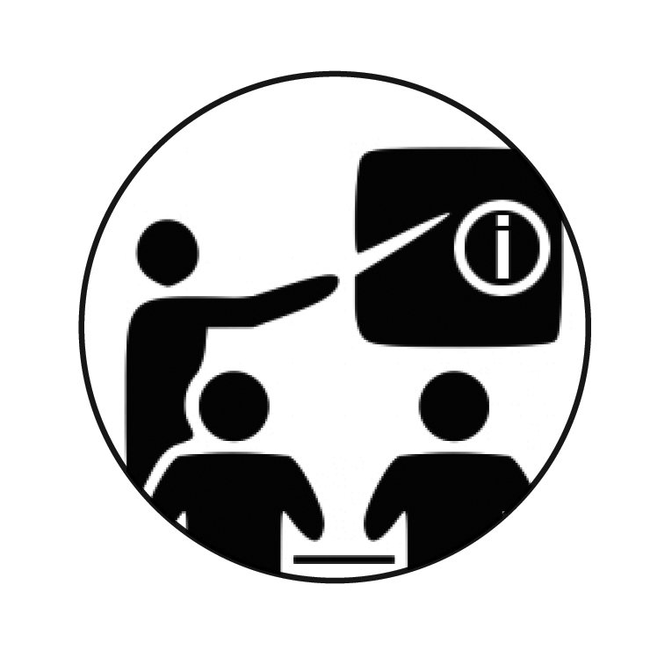2.1.1 – INDUCTION TRAINING
KEY ACTIONS
Induction training is very important in communicating specific health and safety information to employees, contractors and other relevant persons when they first arrive at our workplace.

Induction training will include the following information:

- Specific hazards associated with the workplace and the controls that are in place
- Workplace rules
- Roles and responsibilities
- Emergency procedures and first-aid arrangements.

When inductions have been completed, then We shall complete Form 1.1 Induction Register in Appendix 1. Typical topics which are discussed at induction are also covered in Form 1.2 Typical Induction Topics in Appendix 1.

2.2 – CONSULTATION AND PARTICIPATION
KEY ACTIONS
We recognise that employee participation in health and safety is an integral part of our safety management system. I am/we are committed to providing adequate and appropriate consultation and welcome the views of all employees on issues relating to health and safety.

TOP TIPS
We will consult with all relevant employees:

- When new risk assessments are being carried out or revised
- When there is a change, update or modification to a particular work process
- When new machines or processes are introduced
- When new substances or materials are introduced.

Furthermore, should any of our employees raise any matters relating to their health and safety that are connected in any way to our work activities, We will consider such matters and will endeavour to take any action that We consider necessary or appropriate to deal with the matters raised.

2.3 – THE SAFETY REPRESENTATIVE

KEY ACTIONS
Our employees may select and appoint a safety representative. The appointed safety representative may consult with, and make representations to me/us on safety, health and welfare matters at the place of work.

We shall consider these representations and act on them if necessary. The purpose of these consultations is to prevent accidents and ill health, to highlight problems, and to identify means of overcoming them.
We will facilitate the training of the safety representative so that they have the necessary competence to carry out the task.
The functions of our safety representative include:
- Having given reasonable notice to the employer, regular inspection of the workplace according to a schedule agreed between him/her and the employer that is based on the nature and extent of the hazards in the place of work
- Being given access to information that relates to the safety, health and welfare of employees
- Having the power to investigate accidents and dangerous occurrences subject to any limitations as outlined in the legislation
- Being given the opportunity to receive appropriate health and safety training to help him/her perform the function of a safety representative
- Accompanying an inspector from the Health & Safety Authority during an inspection of the workplace.

Note: The safety representative shall not suffer any disadvantage in their employment through discharging their functions and cannot be held criminally liable for failure to perform any function of a safety representative.
Our safety representative is:

___________________________________________________

2.4 – CONTRACTORS’ RESPONSIBILITIES
Definition: A contractor is a person or organisation which signs a contract to do certain work for payment within a specified time.
KEY ACTIONS
All contractors involved in a work activity on our premises must comply with our policy for safety, health and welfare.
Contractors carrying out work must:
- Be competent to carry out the work
- Have adequate resources to carry out the work
- Provide copies of their own:
  - Safety statement
  - Insurance
- Ensure that work activities do not affect the well-being of our employees, visitors or customers. Ensure they identify potential hazards arising from their work activities and implement appropriate control measures and safe systems of work while carrying out work.
- Report to the designated person on arrival at our workplace.

FURTHER INFORMATION
To ensure compliance with the legislation We will provide contractors with the relevant sections of my /our safety statement or health and safety file (where applicable) to ensure that they are both aware of and can take account of the hazards in our workplace.
Form 1.5 – Responsible Persons Task Register in Appendix 1 can be used to identify employees who agree to carry out key tasks, in this case the overseeing of contractors who may be carrying out work.

2.5 – VISITORS
Definition: A visitor is a person other than an employee or contractor.
KEY ACTIONS
Visitors may not be aware of the potential hazards associated with our place of work. To minimise the risk of injury to visitors, We will:
- Practice good housekeeping, including:
  - Keeping walkways clear
  - Cleaning up spills immediately
- Restrict access to hazardous areas
- Prevent visitors from using equipment or machinery
- Ensure appropriate safety signs and notices are displayed
- Ensure safe walkways and access routes are maintained
- Put procedures in place to ensure visitors are evacuated in a safe and timely manner in the event of an emergency.
Visitors are required to:
- Conduct themselves in a safe manner at all times
- Observe the fire policy and, in the event of an emergency, to identify themselves to an employee and be escorted to the designated assembly point.

2.6 – ACCIDENT REPORTING AND INVESTIGATION
KEY ACTIONS
If an accident or incident occurs in our place of work or in the course of our work activities which has affected employees or a child or visitor, We will:

- Ensure details of the accident are recorded
- Promptly investigate the accident so as to determine the cause and, on completion of the investigation, put in place measures to prevent a re-occurrence
- Ensure that accidents are reported to the Health & Safety Authority on the Form of Notice of Accident (IR1) where:
  - Employees are out of work for more than three consecutive days (including the weekend) and where they cannot continue with their normal duties
  - Members of the public are injured by a workplace activity and require medical treatment
  - A fatal accident has occurred.

FURTHER INFORMATION
The employer of the injured party is responsible for the reporting of accidents on Form IR1 when required.
Any report to the Health & Safety Authority can be made, online, via the HSA’s website, www.hsa.ie, or alternatively by hard copy, i.e. completing the Form of Notice of Accident (IR1) available from the HSA, and posting the completed form to:

Workplace Contact Unit,
Health & Safety Authority,
Metropolitan Building,
James Joyce Street,
Dublin 1.

2.7 – EMERGENCY PROCEDURES
KEY ACTIONS
We will ensure appropriate plans and procedures are in place to deal with emergencies and imminent dangers by:
- Identifying the types of emergency situations that could occur and ensuring that suitable plans and procedures are put in place for dealing with them, e.g.
  - Fire
  - Explosion
  - Accidents/injuries
  - Robbery
  - Missing Child

- Ensuring that employees are trained in the specific plans and procedures we have in place to deal with emergencies at our workplace
- Ensuring that emergency procedures are included in the workplace induction training
- Designating where employees are needed to implement our emergency plans and procedures
- Providing the equipment and training needed
- Completing Form 2.1 Emergency Contact Information in Appendix 2.

FIRE AND EVACUATION
We will ensure appropriate plans and procedures are in place for dealing with fire, and that employees are trained, including:
- Location of firefighting equipment and means to raise the alarm
- Location of assembly point(s)
- Evacuation drills and fire warden(s)
- Location of emergency shut-off points where relevant (e.g. gas) shut off.
Some emergencies (e.g. gas leak, fire, bomb threat, etc.) may require an evacuation of the workplace. The person who become aware (or is made aware) of a potential emergency should follow the emergency procedures. All employees and visitors must follow the procedures below for evacuation:
- GO IMMEDIATELY TO THE NEAREST EXIT
- DO NOT WAIT TO FIND OUT WHAT IS HAPPENING
- DO NOT STOP TO COLLECT PERSONAL ITEMS
- GO AT ONCE TO THEIR ASSEMBLY POINT AND WAIT FOR FURTHER INSTRUCTION
- DO NOT RE-ENTER THE BUILDING/PREMISES UNTIL AUTHORISED TO DO SO BY THE EMERGENCY SERVICES.

FIRST AID
After assessment of the workplace and the type of hazards that exist, We will ensure adequate provision of first-aid equipment and facilities, including:

- At least one adequately stocked and accessible first-aid kit will be provided
- We will ensure first-aid equipment is prominently placed, that employees are aware of its location and that it is accessible to all employees
- We will appoint a person to take charge of first-aid equipment, keeping it stocked and in date (where there is a first aider, they will be given this responsibility)
- Contact details and directions to the nearest doctor or hospital will be available/displayed
- We will appoint an occupational first aider should the workplace assessment identify that a trained occupational first aider is required (considering the specific hazards arising in the workplace, size of the workplace, the numbers employed, access to medical services, etc.).
EMERGENCY CHECKLIST (NON-EXHAUSTIVE) |  | YES | NO | N/A
 | Have you and your employees identified the types of emergency situations that your business could be exposed to (e.g. fire, explosion, chemical spill etc.)?
 | Are employees aware of the plans and procedures?
 | Have employees been appointed and trained in specific tasks, e.g. first aid, fire warden?
 | Are evacuation plans and emergency contact information on display?
 | Are exits well marked, kept clear at all times and emergency lighting/signage in place?
 | Have you held an evacuation drill in the last six months and kept a record of this?
 | Do you and your staff regularly check and maintain the emergency equipment in place (e.g. smoke detectors, fire extinguishers, gas/carbon monoxide detectors, sprinkler systems, emergency lighting)?

VIOLENCE/ROBBERY

Where there is a risk of robbery or violence in the workplace, We will ensure that We have completed a risk assessment for violence/aggression/theft and that adequate plans and procedures are put in place. We will train staff on how to deal with the threat of robbery/violence, for example:
- Keep calm and make no sudden movements
- Do what the offender asks
- Memorise as many details about the offender as possible, e.g. height, clothing, features
- Note the direction and method of escape, e.g. car, motorbike, on foot
- Notify the Gardaí as soon as it is safe to do so
- Provide first aid to victims
- Lock outside doors until emergency services arrive.

2.8 – WELFARE FACILITIES AND WORKPLACE REQUIREMENTS

KEY ACTIONS
Where required, We will provide and maintain adequate welfare facilities and a suitable and safe workplace environment for use by our employees and children, including but not limited to:
- Toilet facilities
- Canteen and food preparation areas
- Changing areas
- Adequate ventilation, temperature and lighting
- Interior walls, floors and traffic routes that are maintained in good condition and kept clean
- Fire detection and fire-fighting equipment
- Emergency routes and exits

WELFARE FACILITIES | DETAIL AS NECESSARY
Toilet facilities (separate male and female if required) | Staff Toilets on first floor  Childrens toilets on ground and first floor
Washbasins and washing facilities (hot and cold water and soap) | In all toilets
Accommodation to take meals. Ability to boil water, clean surfaces, seating with backs, adequate lighting and heat | Staff Room in attic
Potable drinking water | In kitchen and staff room
Facilities to dry clothing and suitable changing areas for nature of the work | Tumble Dryer in Children’s bathroom on 1st Floor

2.9 – PERSONAL PROTECTIVE EQUIPMENT
KEY ACTIONS
Appropriate personal protective equipment (PPE), as identified in our risk assessments, is provided and must be worn by our employees.
- Disposable Gloves to be used when changing nappies; and
- Cleaning any spillages.
We will ensure that:
- Adequate and suitable gloves are provided

We expect our employees to:
- Use gloves as required
- Report when stocks of disposable gloves are running low
- Inform me/us of any medical conditions they have that might be affected by the use of the gloves provided to them.

2.10 – PREGNANCY AT WORK
KEY ACTIONS
As required by Part 6 of the Safety Health and Welfare at Work (General Application) Regulations 2007, on becoming aware that an employee is pregnant, has recently given birth or is breastfeeding, We will assess the specific risks arising to that employee from the work and take action to ensure that she is not exposed to anything that would damage her health or that of her developing child. On provision of an appropriate medical certificate, We will carry out the following:
- Make sure that a specific risk assessment for that employee is undertaken, taking account of any medical advice that the employee has received
- Assess any risk likely to arise from exposure to contagious infections and work activities and, where possible exposure exists, ensure she does not carry out these activities
- If a risk cannot be eliminated or reduced to an acceptable level, then If this is not possible, grant the employee health and safety leave
- I /we will ensure that pregnant, postnatal or breastfeeding employees have suitable facilities to rest or feed
- Form 1.5 Responsible Persons Register in Appendix 1 can be used to identify the person responsible for carrying out pregnancy-at-work risk assessments.

2.11 – STUDENTS
KEY ACTIONS

To ensure the safety and welfare of any college students we will ensure the following:-
- Students will never be left unattended with children.
- Students will be given a full induction upon starting at Kilnamanagh Kids.
- Students will not open the front door or admit any person onto the premises.
- They will only work the hours that their college has set.
- We will take into account their relative lack of experience, absence of awareness of potential risks or lack of maturity when setting tasks.
- We will put in place all required control measures identified by the risk assessment, taking account of:
  - Their lack of experience, maturity or awareness of risk
  - The physical and psychological capacity of the young person
- Form 1.5 Responsible Persons Register in Appendix 1 can be used to identify the person responsible for carrying out young persons at work risk assessments.

2.12 – WORK-RELATED STRESS AND DIGNITY AT WORK
KEY ACTIONS
As an employer We will, so as far as is reasonably practicable, ensure that:
- No employee’s workload is so great that he or she will have to consistently work overtime
- No employee will be subjected to harassment from, or degrading behaviour by, colleagues or managers and that everyone in the workplace treats others with respect and courtesy, even if they do not ‘get along’
- No employee has to work in an environment which is unsafe and in which there are risks of accidents
- Employees are trained so they can do their jobs effectively and safely
- Everyone knows what his or her core job is
- That Staff Policy and Procedures are in place that outline procedures with regard to addressing bullying and harassment at work.

APPENDICES

APPENDIX 1 – FORMS AND RECORDS

APPENDIX 2 - EMERGENCY INFORMATION

APPENDIX 3 – ACCIDENT REPORTING AND INVESTIGATION

APPENDIX 4 – SAFETY DATA SHEETS

APPENDIX 1 – FORMS AND RECORDS

FORM 1.1 – INDUCTION REGISTER

INDUCTION REGISTER
NO. | NAME | DATE INDUCTED | SIGNATURE

FORM 1.2 – TYPICAL INDUCTION TOPICS

FORM 1.3 TRAINING REGISTER
TRAINING REGISTER
NO. | NAME | TRAINING TYPE | TRAINER | SIGNATURE | DATE

FORM 1.5 – RESPONSIBLE PERSONS TASK REGISTER
RESPONSIBLE PERSONS TASK REGISTER
NO. | TASKS (NON-EXHAUSTIVE) | RESPONSIBLE PERSON (WHERE REQUIRED) | SIGNATURE
 | Ensuring the safety statement, including risk assessments, is up to date, accessible and available to all | Deirdre Lawlor
 | Person responsible for managing and co-ordinating work activities | Sandra Casey
 | Ensuring records are maintained | Sandra Casey
 | Ensuring forms and registers are collected and filled out as required | Sandra Casey
 | Ensuring safety data sheets are available and appropriate control measures are in place | Sandra Casey
 | Ensuring accidents are investigated, reported and remedial measures implemented to prevent re-occurrence | Deirdre/Sandra
 | Ensuring risk assessments are carried out and updated as necessary | Deirdre/Sandra
 | Ensuring the upkeep and maintenance of welfare facilities | Deirdre/Sandra
 | Ensuring the upkeep of the first-aid box and ordering of first-aid supplies | Sandra Casey
 | Co-ordinating and managing training requirements | Sandra Casey
 | Ensuring the upkeep and maintenance of the premises and co-ordination of contractors’ activities | Deirdre Lawlor
 | Ensuring young persons risk assessments are carried out when necessary | Sandra Casey
 | Ensuring pregnancy-at-work risk assessments are carried out when necessary | Sandra Casey
 | Managing provision of emergency equipment and co-ordinating procedures, including provision of fire extinguishers, fire drill, evacuation planning, etc. | Deirdre Lawlor

APPENDIX 2 – EMERGENCY INFORMATION

FORM 2.1 – EMERGENCY CONTACT INFORMATION
EMERGENCY CONTACT INFORMATION
BUSINESS/COMPANY NAME | KILNAMANAGH KIDS CRECHE
ADDRESS | 36 TAMARISK LAWN  KILNAMANAGH  DUBLIN 24
PREMISES CO-ORDINATES |  |  | N |  |  |  | W
CONTACT DETAILS
NAME | ROLE |  |  |  |  | PHONE NUMBER
Deirdre Lawlor | Owner Manager |  |  |  |  | 0872871530
Sandra Casey | Manager |  |  |  |  | 0871534770
EMERGENCY SERVICES CONTACT DETAILS
SERVICE | ADDRESS |  |  |  |  | PHONE NUMBER
DR DURKIN | Redwood, Kilnamanagh |  |  |  |  | 4513589
FIRE/GARDAÍ/AMBULANCE |  |  |  |  |  | 999 OR 112
UTILITY AND SERVICE PROVIDERS
ELECTRICITY (ESB NETWORKS) |  | 1850 372 999 (24HR)
GAS NETWORKS IRELAND |  | 1850 20 50 50 (24HR)
IRISH WATER |  | 1890 278 278
HEALTH & SAFETY AUTHORITY |  | 1890 289 389
ASSEMBLY AREA |  | See individual room plans
EMERGENCY CO-ORDINATOR(S) | NAME |  |  |  | PHONE

FORM 3.1 – INTERNAL ACCIDENT/INCIDENT INVESTIGATION FORMAPPENDIX 3 – ACCIDENT/INCIDENT INVESTIGATION FORM
ACCIDENT/INCIDENT REPORT FORM

Child’s Name: _______________________________________________________
DOB: ________________________________________________________

DETAILS OF ACCIDENT/INCIDENT
Date: ________________________ Time: __________________________

Description of accident/incident (nature of any injury/illness etc.):
_____________________________________________________________________

_____________________________________________________________________

_____________________________________________________________________

_____________________________________________________________________

Who was present at the time?
_____________________________________________________________________

Actions taken and by whom?:

_____________________________________________________________________

_____________________________________________________________________

_____________________________________________________________________

Parents/Guardian contacted: Yes/No
GP contacted: Yes/No
Ambulance/hospital contacted: Yes/No
Comments/any follow on action required?
_____________________________________________________________________

Staff Signature: Date:
Parent/Guardian Signature: Date:
Manager Signature: Date:

After a bump to the head it is recommended to look out for any signs of concussion:-
Symptoms include:
- Headaches
- Dizziness
- Trouble with balance
- Nausea/vomiting
- Confusion
- Blurred vision
- Lethargic/difficulty waking
- Loss of consciousness

If your child displays any of these symptoms we advise you to seek medical attention.

The above information on concussion has been explained to me.

Signed _______________________________
Staff

Signed _______________________________
Parent

Signed _______________________________
Manager

SAFETY REPORT (To be filled by management)

Was this incident caused by any breach of our Safety Statement? YES / NO

If Yes can you please describe below how the safety statement was breached.

___________________________________________________________________

___________________________________________________________________

What procedures should be put in place to ensure there is no reoccurrence of this type of incident?

__________________________________________________________________

__________________________________________________________________

APPENDIX 4 - SAFETY DATA SHEETS/REPORTS FOR HAZARDOUS SUBSTANCES
SAMPLE SAFETY DATA SHEET INFORMATION BRIEF
The safety data sheet (SDS) is provided to inform you of the hazards of the chemical you are using and the measures you need to take to protect your health and that of your employees. It consists of 16 obligatory sections. Each section contains specific information relating to the chemical for which the SDS is prepared. You must have an SDS for each hazardous chemical you receive from a supplier. The following serves as an aid in helping you to understand what information you should be aware of and what information you need to take into account when completing the risk assessment for the chemicals you use.
Section 1 contains contact details of the person/company responsible for supplying the chemical as well as the emergency telephone number to contact in case of an emergency.
Section 2 gives details on the hazards of the chemical. This will help you assess the risk and what harm it can do to your health, the health of your employees and the environment.
Section 3 If the chemical you are using is a preparation (mixture), this section will give you information on the hazards of each of the individual substances in the preparation.
Section 4 details the first-aid measures you need to take in case of an accident while using the chemical.
Section 5 gives specific information on fighting a fire caused by the chemical.
Section 6 details what actions need to be taken if there is an accidental release of the chemical, such as what protective equipment to wear and how to clean up the spill.
Section 7 contains details on how to handle and store the chemical safely. The information in this section should be used to help you put in place safe procedures for working with chemicals.
Section 8 gives you details of the steps you need to take to reduce exposure and of the personal protective equipment you need to wear when working with the chemical to protect yourself.
Sections 9, 11 and 12 provide detailed information on the physical/chemical, toxicological and ecological properties of the chemical.
Section 10 contains details of any hazardous reactions that may occur if the chemical is used under certain conditions.
Section 13 explains how the chemical should be disposed of correctly.
Section 14 contains information relating to the transportation of the chemical.
Section 15 contains the details of the classification of the chemical as given on the label.
Section 16 gives any other information relevant to the chemical, e.g. training advice.

APPENDIX 6 – RISKY PLAY POLICY AND RISK ASSESSMENT FORM

RISKY PLAY POLICY
When you entrust the care of your child to Kilnamanagh Kids you must be able to do so secure in the belief that your child is being well cared for, that their learning and development needs are being met and that they are kept safe at all times. We achieve this by operating within the Siolta framework that ensures that the safety and protection of young children is always our first priority.
We will always ensure through ongoing checks and vigilence that the children in our care are provided with safe and secure environments in which to interact and explore rich and diverse learning and development opportunities.
However children cannot be wrapped in cotton wool and it is only through exploration that they learn about the world. If we remove every obstacle or activity which has any risk attached, we are depriving children of the opportunity to learn how to manage difficult situations and assess risk.
For example, the risk of falling off larger pieces of play equipment is quite high; however, the risk of harm is minimised by ensuring that there is adequate supervision, correct positioning of the equipment (away from windows, or walls), crash mats, and some ‘rules’ set by adults that are appropriate for the individual child’s level of understanding. In order to remove all risk the use of such equipment would be banned altogether, but the benefits of the activity happening, with the risk that some children will fall, includes children being able to expand their skills, as they risk climbing higher, reaching further, or balancing for longer. Children will also learn how to fall, how to pick themselves up and start over again. Equally importantly, they will begin to understand the consequence of taking risks beyond their current ability.
In order to minimise risk we carry out the following assessment for any activitiy deemed to be risky. Once the risk assessment is carried out and we are happy that the chance for learning outweighs the risk we will go ahead with the activity. Parents need to be conscious of the fact that having assessed all risks that accidents may still happen.
RISKY PLAY ASSESSMENT
ACTIVITY | RISKS/HAZARDS | WHO COULD BE HARMED AND HOW | ACTION NEEDED | BY WHOM | FEEDBACK

PART B1 - RISK ASSESSMENTS
Hazard Name  Electricity | Current Controls  All new electrical installations are tested and certified as safe by a qualified electrician.  Plug covers are placed on all plug holes when not in use to prevent contact with electricity  Damaged extension leads are repaired or replaced  Trips switches are provided and employees are aware of their locations  Work on live electrical equipment is avoided when children are present where reasonably practicable | Additional Controls

Hazard Name  Fire | Current Controls  Amounts of flammable materials are minimised and waste is removed (Keep workplace clean and tidy) daily  Fire alarm, manual call points and smoke/heat detectors are in place, kept in good working order and checked (annual checks by a competent person)  Emergency routes and exits are clearly marked, kept clear at all times and lead directly outside or to a safe area  Fire extinguishers are accessible, kept in good working order and inspected regularly  Employees are trained in how to raise the alarm, what to do in the event of an alarm sounding, emergency evacuation procedures and in the use of fire extinguishers  Emergency evacuation procedures are in place  Fire drills are held regularly  Appropriate signage (e.g. assembly point(s), fire point(s)) is in place  Fire doors are installed at the entrance to all down stairs rooms | Additional Controls

Hazard Name  Outbreak of contagious disease | Current Controls  Prevention of Contagious Diseases Policy in place to ensure outbreaks are kept to a minimum | Additional Controls  Emergency Plan in place in the event of outbreak

Hazard Name  Severe allergic Reaction | Current Controls  All children’s allergies are noted in the kitchen  Staff are made aware of allergies for specific children in their care  Staff trained in Paediatric First Aid | Additional Controls  Emergency Plan in place in the event of a severe allergic reaction

Hazard Name  Sudden Infant Death Syndrome | Current Controls  Safe sleep policy | Additional Controls  Emergency Plan in place in the event of Sudden Death

Hazard Name  HOT FOOD | Current Controls  All hot food being served to the children from the kitchen is checked to ensure it won’t burn children mouths  No hot drinks can be consumed out of the kitchen/staff room.  The microwave is not used to heat bottles | Additional Controls  Food is plated up 5 minutes before serving

Hazard Name  Falling Objects/Stacking High | Current Controls  Staff should ensure that chairs are stacked no more than 5 high to prevent stack falling on children  Each piece of free standing material is assessed to ensure it is not a falling hazard for children and if required fixed to the wall  No trailing wires should be left hanging down from shelves to ensure children don’t pull equipment down on themselves | Additional Controls

Hazard Name  Slips, Trips and Falls | Current Controls  Clear, unobstructed, slip-resistant pedestrian routes (Including entrances and exits) are provided and maintained  Adequate lighting is provided and is appropriate for the work being carried out  Absorbent materials and warning signage are available for dealing with spills  Spills are cleaned up immediately  Mats are properly located, fitted and secured  Trailing cables and leads are re-routed, removed or secured  Good house-keeping practices are in place and are maintained | Additional Controls

Hazard Name  Manual Handling | Current Controls  Each manual handling task is assessed (Using the risk factors) and measures put in place where needed to avoid or reduce the risks  Bending, twisting and unstable postures are avoided  Employees receive relevant manual handling training where necessary  When changing an older child's nappy the child should be encouraged to climb onto the changing area rather than being picked up. | Additional Controls

Hazard Name  Chemicals | Current Controls  A list (inventory) of all chemicals used in the workplace has been prepared  Less hazardous chemicals are used where possible  Adequate ventilation is provided  A wash hand basin, soap and disposable towels/hand dryer are available  All chemicals are used, stored out of reach of children | Additional Controls  Chemical labels (Label applied to containers of dangerous chemicals to indicate the risk and precautions to be taken) and Safety Data Sheets are available for each chemical and the associated hazards of each chemical has been identified  Employees are trained in the safe use of chemicals

Hazard Name  Driving for Work | Current Controls  Employees have a full drivers licence (Valid driving licence is carried and is appropriate to the vehicle being driven, are competent, authorised and experienced and are familiar with the vehicle  Vehicles are maintained in accordance with the manufacturer's instructions, in a roadworthy condition and fit for use  The use of hand held equipment (e.g. hand held phone or electronic device)is not allowed while driving  Employees are trained in safe driving practices  Safe practices and suitable aids (e.g. where it is safe to reverse, well positioned mirrors, use of reversing alarms etc) are used for reversing and aids are kept in good working order  Children can only be transported in staff cars is the appropriate insurance is in place and appropriate car seats are available | Additional Controls  (See Action List)  A driving for work policy is in place and is communicated to all employees  Insurance relating to transporting children in staff cars is kept on premises  Vehicles are parked safely and legally  In the event of breakdown the vehicle is safely (Try to park in as safe a place as possible. Avoid stopping on bends, narrow road sections or where there is reduced visibility) stopped, hazard warning lights are activated and warning triangle is used where appropriate

Hazard Name  Dispensing Drugs and Medicines | Current Controls  Medicine Administration Policy is in place  All Staff are aware of policy | Additional Controls

Hazard Name  Contaminated Waste Disposal | Current Controls  All materials used for cleaning potentially contaminated areas, are confined for use to that area  Bins with foot pedals are used and disposable gloves are provided and worn  Waste is collected and disposed of by a licensed contractor | Additional Controls

Hazard Name  Dishwasher / Glass Washer  Contact with dishwasher/glass washer can cause scalds, cuts and other serious injuries to you, your employees and/or visitors | Current Controls  Machine is installed, used and maintained in accordance with the manufacturer's manual  Hot water cycle stops automatically if door is opened  Employees are trained in the use of the dish/glass washer and operator's manual is available  Baskets are not overloaded | Additional Controls  Warning signs are in place

Hazard Name  General Equipment  Use of defective equipment or wrong use of equipment may cause cuts, bruises, electric shock, back, crush or other serious injuries to you, your employees and/or visitors | Current Controls  Equipment is used and maintained in accordance with the manufacturer's instructions  Equipment is maintained in good condition, reported defects are dealt with promptly and unsafe equipment is taken out of use  Employees are trained in the safe operation of equipment | Additional Controls

Hazard Name  Hob | Current Controls  Heat resistant gloves are provided and worn  Children are not allowed in the kitchen area while the cooker is on. | Additional Controls

Hazard Name  Handling Raw Meat  Contact with raw meat can cause infection or ill health to you, your employees and/or visitors | Current Controls  Good hygiene practices (To prevent the spread of germs that could cause food poisoning) are used when handling raw meat  Protective gloves are provided and worn  A HACCP system is in place in the kitchen | Additional Controls

Hazard Name  Heating System | Current Controls  All ventilation, heating and air conditioning systems are used and maintained in accordance with the manufacturer's instructions  Accessible hot pipework is lagged as required  Equipment is kept in good working order, reported defects are dealt with promptly and unsafe equipment is taken out of use | Additional Controls

Hazard Name  Hot Objects  Contact with hot objects, surfaces and products can cause burns and scalds to you, your employees and/or visitors | Current Controls  Ovens, radiators and piping are insulated, guards are provided or temperature is controlled  Care is taken when moving hot objects or liquids around the workplace  No hot drinks or food should be taken outside the kitchen or staff room | Additional Controls  (See Action List)  Warning signs are in place  Heat resistant gloves are provided and worn where relevant

Hazard Name  Knives and Sharp Objects | Current Controls  Use of knives and sharp objects is minimised and they are stored safely in the kitchen  Safe work practices are in place for the use, cleaning and sharpening of knives and sharp objects and employees are trained  Knives or sharp object used are suitable for the job | Additional Controls  (See Action List)  Knives and sharp objects are checked (e.g. blade seating, blade and overall condition of knife) before use, reported defects are dealt with promptly and unsafe equipment is taken out of use  Blades are kept sharp and replaced as needed

Hazard Name  Microwave | Current Controls  Microwave is used and maintained in accordance with the manufacturers manual  Metal is never placed in the microwave  Reported defects are dealt with promptly and unsafe equipment is taken out of use  Containers used are suitable for use in the microwave  Heat resistant gloves/cloths are provided and used when handling hot containers | Additional Controls  (See Action List)

Hazard Name  Oven/Range | Current Controls  Oven/range is installed, used and maintained in accordance with the manufacturer's instructions  Handles of pots/pans are secure and they do not project beyond the edge of the hob or range  Ladles or spoons are not left in saucepans on hotplates or rings  Heat resistant gloves are provided and used  Oven is not used if the fan guard is not in place  Reported defects are dealt with promptly and unsafe equipment is taken out of use  Bottom-hinged oven doors are not left open | Additional Controls  (See Action List)

Hazard Name  Tumble Dryer | Current Controls  Tumble Dryer is stored out of reach of children  Lock on doors should always be pushed across when dryer is unattended  No plastic bibs are dried in dryer  The Dryer is not overloaded  The water container in the tumble dryer should be checked regularly to avoid leaks | Additional Controls

Hazard Name  Risky Play | Current Controls  Risky Play Policy in place and Risk Assessment (Appendix 6) | Additional Controls

Employees Declaration

I hereby declare that I have read the safety statement and understand it contents and I will comply with it requirements

Name ( block capitals) | Signature date | Comments

Employees Declaration

I hereby declare that I have read the safety statement and understand it contents and I will comply with it requirements

Name ( block capitals) | Signature date | Comments

